**DATA FLOW DIAGRAM**

**Context Level**

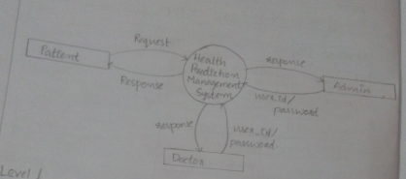

**Level1**

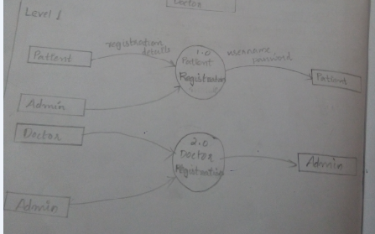

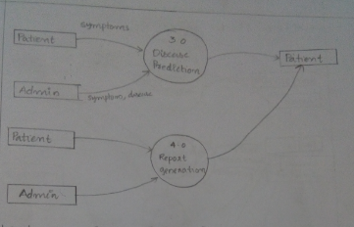

**Level 1.0 : Patient Registration And Activities**

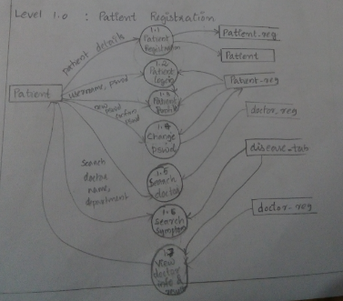

**Level 2.0 : Doctor Registration And Activities**

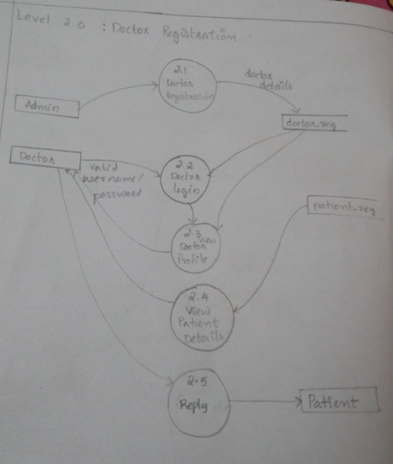

**Level 3.0 : Disease Prediction**

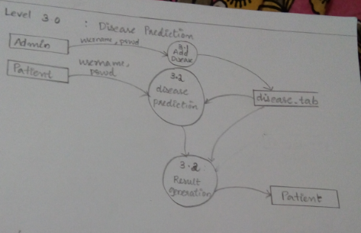

**Level 4.0 : Report Generation**

